State Records Center, Records Management Branch (RMB) Boxes:
Heavy-duty, triple-end, double-side, double-bottom construction.
Stacking weight is 850 lb.
Reinforced tear-resistant hand holes.
Deep, locking liftoff lid.
Smooth rolled edges.
One Step Setup.
Interior Dimensions: 15”L x 12”W x 10”H.
Exterior Dimensions: 16.5”L x 12.75”W x 10.38”H (including closed lid).
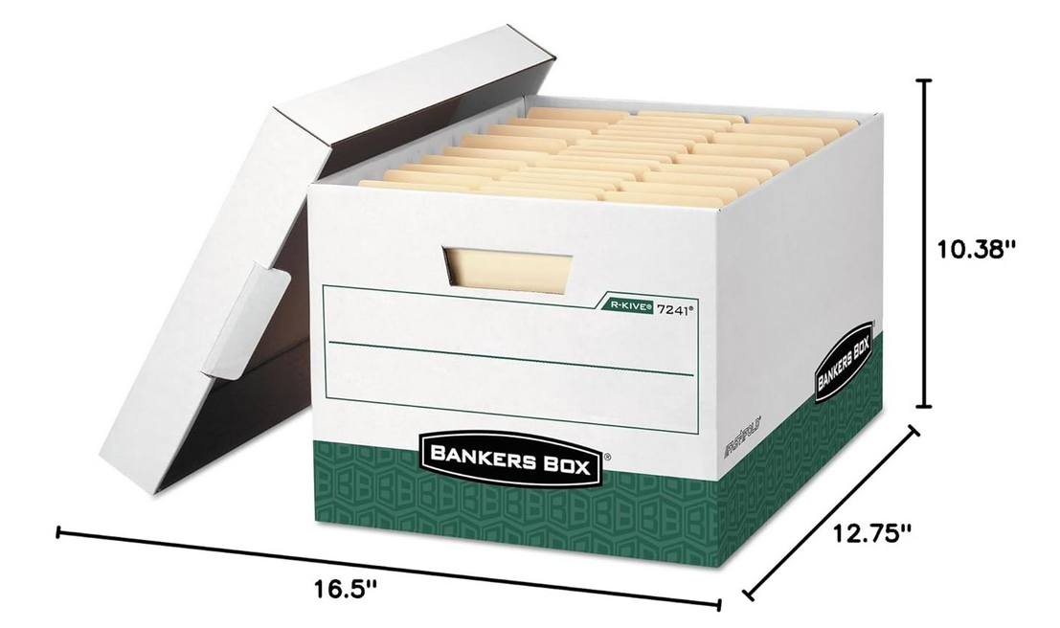

Attached are the graphics for the box:
- On top surface of the lid – centered with 1 inch margin all around


- On sides of the lid – centered
- On both short sides of the box – fill space below handle, margin 1 inch left, right and bottom. The SRC RFID Label area is 4 (horizontal) x 3 (vertical) inches.
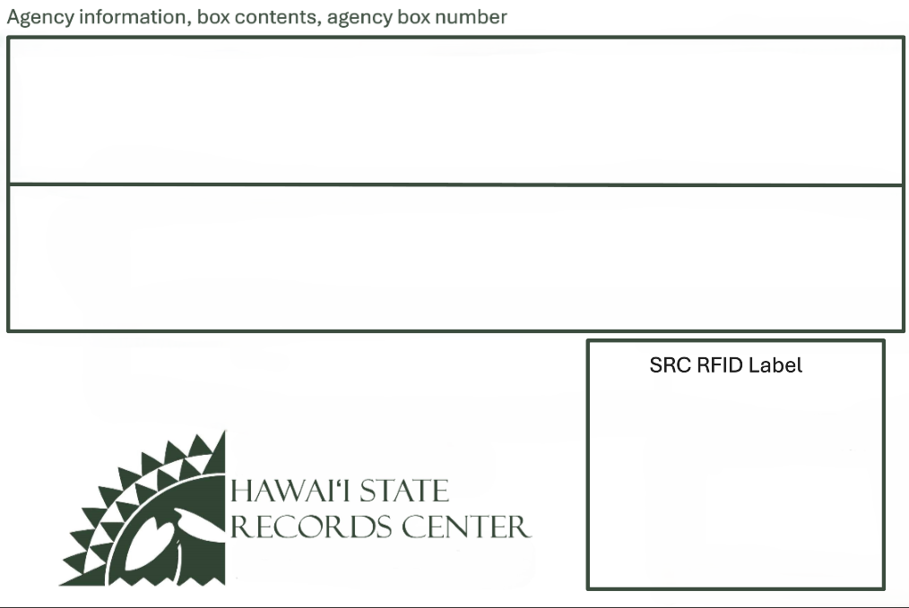

- On both long sides of the box – centered, use same graphic as the top of box lid, centered with 1 inch margin all around.

FIG. 1
FIG. 2

